The TCP Server

Javier Bermejo EA1AUS, Aki Yoshida JA1NLX, Williams VE7TK, Ron W4LDE and Prasad VU2PTT

1.0 GENERAL

The TCP Server provides an interface to any TCP client like JTDX or JTAlert the evaluation version of JTDX (a program written by UA3DJY for Digital modes JT65, JT10, T9, and WSPR-2).

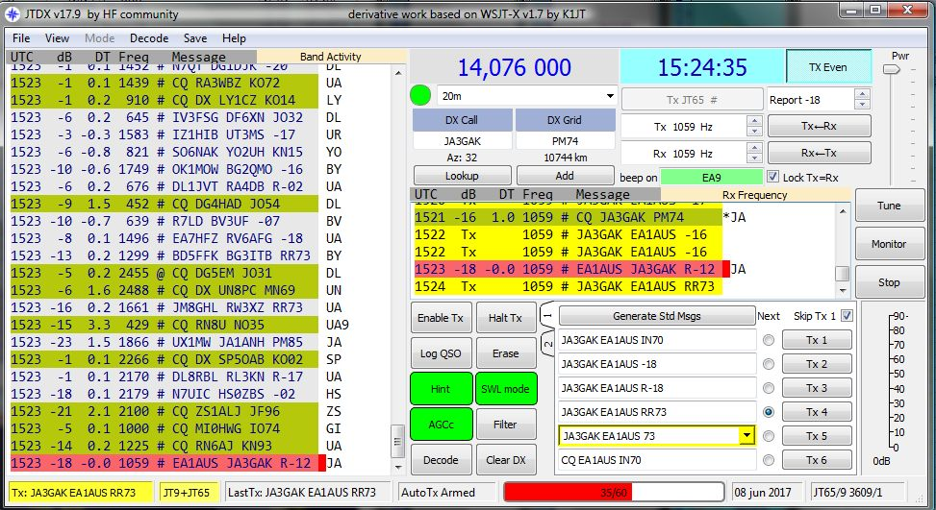

TCPS_1

This is a bridge between Logger32 and JTDX. When the port of TCP Server is opened in Logger32, any JTDX QSO data for the modes listed above can be transferred automatically to Logger32, and Logger32 will log this QSO in the current Logbook.
If you use WSJT-X with JTAlert WSJT-X QSO data can be transferred to Logger32, and Logger32 will log this QSO in the current Logbook as well. Add on software, SOCAT 1.7.3 is required for proper transfer.

WSJT-x / JTAlert has the capabilities to include call book lookup data in addition to the basic logging provided without call book provided by QRZ.com and HamQTH.com to name a few.

The following site are is to download the latest stable version of these programs. JTDX and online help.

JTDX:

http://www.qrz.lt/ly3bg/JTDX/jtdx.html

WSJT-X:

https://physics.princeton.edu/pulsar/k1jt/wsjtx.html

JTAlert:

http://hamapps.com/

SOCAT:

https://github.com/tech128/socat-1.7.3.0-windows

2.0 Configuration.

2.1 Configuration in Logger32

  - Open the TCP Server from “View” option in main menu of Logger32 and Click File.
  - Click to Close Port : Click to close port or open port
  - Popup on connect:: The TCP Server window appears when it is connected to client if this option is checked.
  - Hide: Click to hide TCP Server window.
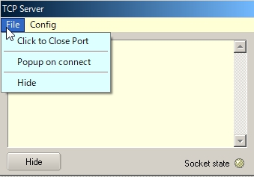

TCPS_2

Click Config to see the Host ID (PC name for this PC), the Local IP, IP address and Port number.

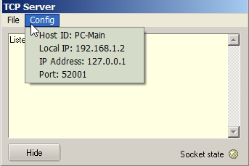

TCPS_3

The Socket state LED shows port/connection status .

  - Red: Port is closed;
  - Orange: Port is opened but no connection established (or no connection request from JTDX); and
  - Green: Connection established while JTDX or JTAlert is sending QSO data.

This status is also displayed in the lower status bar.

Move the cursor to the TCP pane. If the port is opened the text is highlighted with Blue color. If the port is closed the text is highlighted with Red color.

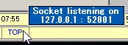

TCPS_3A

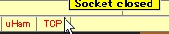

TCPS_3B

Right click on the TCP pane to show the Server menu.

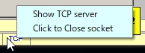

TCPS_3C

2.2 Configuration in JTDX

JTDX may be installed not only in the same PC as Logger32 but diffrent PC if both PC are connected with LAN.

Open the Reporting tab on JTDX settings, look for External logbook connection section. You see “127.0.0.1” as TCP Server and “52001” as TCP Port. These are default values.

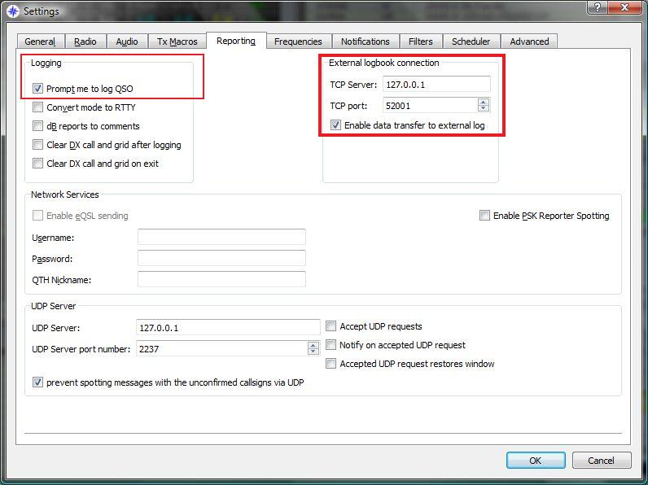

TCPS_4

If JTDX is installed in the same PC as Logger32 then leave TCP Server and TCP port as they are. If JTDX is installed in the different PC then enter the Local IP as the TCP Server which you see in Logger32 TCP Server. (TCPS_3) Leave the TCP Port as it is. In this case the TCP Server tooltips are displayed like this once connection is established.

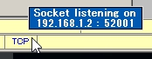

TCP_4A

Check "Enable data transfer to external Log" option.

It's preferable to also check "Prompt me to log QSO" in Logging section. This way whenever we send a goodbye message, we will see the QSO data waiting to be transfered to logger32.

Click OK to save settings.

The following graphic shows the fields of the QSO waiting to be transferred to Logger32.

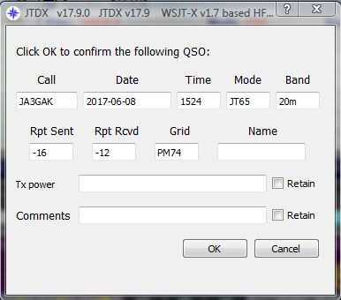

TCPS_5

2.3 Configuration in WSJT-X/JTAlert
JTAlert receives QSO data from WSJT-X via UDP port and send it to Logger32 via TCP port. Following are general step-by-step of configuration.
Details are provided by Prasad, VU2PTT at: https://goo.gl/cHBKhr

(1) Download SOCAT the Ten (10) files at https://github.com/tech128/socat-1.7.3.0-windows
(2) Save files in a C:/ folder.
(3) In the JTAlert Settings window, select Logging marked on the left in the picture below, click on Standard ADIF File, click on the Enable Standard Logging check box, create a new log by clicking on Create New and create a new ADIF log with a filename you wish to use. Click on OK.

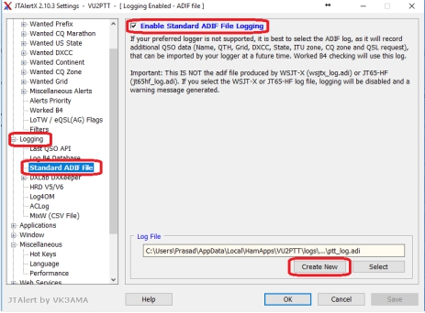

TCPS_5A

(4) In the JTAlert Settings window, select Auto_Start marked on the left in the picture below.

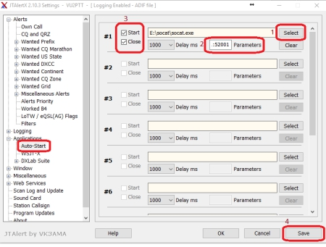

TCPS_5B

(5) On the right side of this window we will configure JTAlert to use SOCAT and also automatically start and stop it whenever JTAlert is opened and closed.
(6) Click on Select button (1) and use the browse window that pops up to go to the folder where you saved the SOCAT utility. Select the file socat.exe and click on the Open button of this window.
(7) Next in the textbox marked Parameters (2) copy and paste the following command parameters for SOCAT: Copy exactly, do not add or delete spaces if entering data manually.
-d -v -T30 -ly UDP4-LISTEN:52001,fork,bind=127.0.0.1 TCP4:127.0.0.1:52001
(8) Make sure the Start and Close checkbox (3) on the left of these fields is checked as shown in the picture above.
(9) Now click on the Save button (4) at the bottom of the JTAlert window.
(10) Now in the Logging section of the JTAlert Settings window, select the Last QSO API option as marked in the picture below.
(11) Make sure the UDP Port setting is the same as the TCP Port setting seen earlier in Logger32 TCP Server configuration (default in Logger32 is 52001).
(12) Once this is set, click on OK.
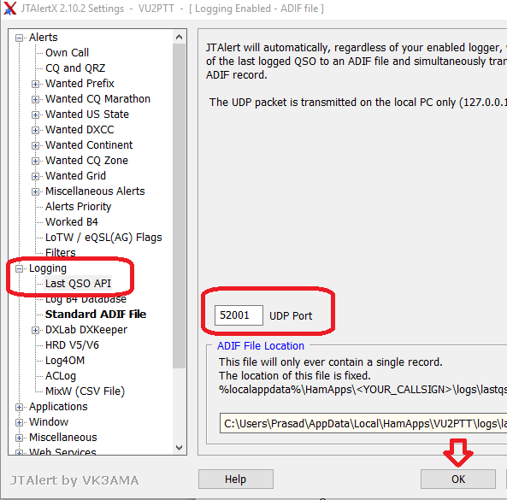
TCPS_5C
(13) Logging data provided via the TCP port without XML call book service are:

Date, Time ON, Time OFF, RST RX, RST Sent, Grid, Name (If entered manually in the WSJT-x log pop-up
Window) and two other manual entries which are TX power and comments, again in the WSJT-x log Popup window.

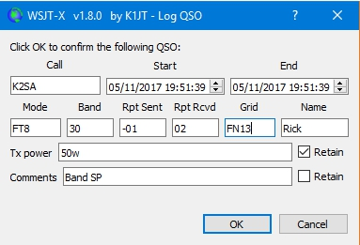

TCPS_5D

If you wish you can configure JTAlert to include CALL Book information when logging a QSO through the TCP port. In JTAlert settings, select WEB SERVICES, Refer to Online XML call books TCP_5E per your preference. Click OK to save setting.

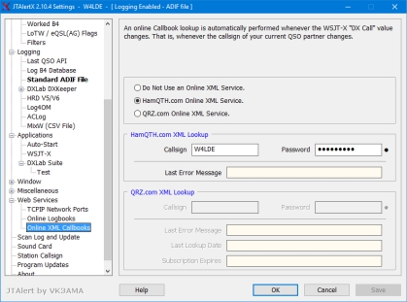

TCPS_5E

3.0 OPERATION
3.1 JTDX

Open the TCP Server using the View menu item of the Main menu in Logger32 and open the port. (Next time you start Logger32, this action will be remembered)

Log the QSO in JTDX. QSO data are momentarily displayed in Blue text in the TCP Server window. This QSO is logged automatically in the current Logger32 Logbook. Example of traffic received through the TCP Server is shown below.

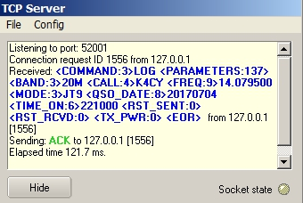

TCPS_6

3.2 WSJT-X/JTAlert
Leaving WSJT-X and Logger32 running, shut down and restart JTAlert. If everything is configured correctly, the SOCAT utility command window should pop up with a blank screen. This is where the magic happens. You can leave this SOCAT window open and resize/move it to a corner of the screen or even minimize it later once everything is working fine. Now make a QSO in WSJT-X and log the QSO. This is what will happen:
(1) The SOCAT window will now show the ADIF string sent out over the UDP port configured in JTAlert. This is what it looks like:

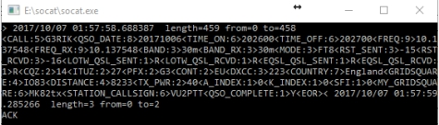

TCPS_6A

(2) The Logger32 TCP Server will show the incoming ADIF string from SOCAT.

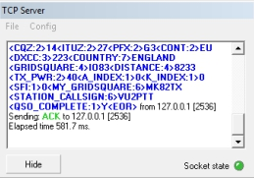

TCPS_6B

(3) And the Logbook Page Window of Logger32 shows the logged QSO

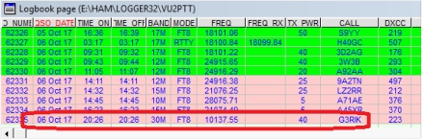

TCPS_6C

(4) Logging via TCP using JTAlert with WSJT-X

Note by Ron, W4LDE:

If you have configured a XML call book lookup in JTAlert settings and depending on the data provided service, Logger32 log will save the following, they are:

A call book server such as HamQTH will provide, including ADDRESS, SFI, A-index, K-index, BAND_RX, CALL, CONT, COUNTY, CQZ, DISTANCE, DXCC, FREQ_RX, GRIDSQUARE, ITUZ,MODE, NAME, QSO_DATE, QTH, RST_RCVD, RST_SENT, TX_PWR, STATE, PFX to name a few.

The actual data provide through the TCP connection is a subject of data provided to JTAlert from the call book service and WSJT-x.

From actual data transferred to Logger32. Note the difference between log book service on and off.

Service turned on in JTAlert. Common data highlighted

<CALL:5>WT9WT<QSO_DATE:8>20171104<TIME_ON:6>190100<TIME_OFF:6>190200<FREQ:6>10.136<FREQ_RX:6>10.136<BAND:3>30m<BAND_RX:3>30m<MODE:3>FT8
<RST_SENT:3>-03<RST_RCVD:3>+04<GRIDSQUARE:6>EM59DT<DISTANCE:3>829
<TX_PWR:2>50<A_INDEX:1>9<K_INEX:1>1<SFI:2>73<NAME:7>William<QTH:11>Springfield
<STATE:2>IL<CQZ:1>4<ITUZ:1>8<PFX:3>WT9<CONT:2>NA<CNTY:11>IL,Sangamon<ADDRESS:67>William W Tinsley, 114 Calvin, Springfield, IL 62704, United States<DXCC:3>291<COUNTRY:13>United States<MY_GRIDSQUARE:6>EM73ol<MY_CQ_ZONE:1>5<MY_ITU_ZONE:1>8<STATION_CALLSIGN:5>W4LDE<QSO_COMPLETE:1>Y<EOR>

Now compare the difference between a service turned off.

Online Call Book service turned OFF

<call:5>VE7ON <gridsquare:4>CN89 <mode:3>FT8 <rst_sent:3>+04 <rst_rcvd:3>-12
<qso date:8>20171105 <time_on:6>154945 <qso_date_off:8>20171105 <time_off:6>155045 <band:3>30m <freq:9>10.137933 <station_callsign:5>W4LDE <my_gridsquare:6>EM73ol <tx_pwr:3>50w <eor>

Online Call book service turned back on Data added highlighted

<CALL:4>KU0D<QSO_DATE:8>20171105<TIME_ON:6>155200<TIME_OFF:6>155300<FREQ:6>10.136<FREQ_RX:6>10.136<BAND:3>30m<BAND_RX:3>30m<MODE:3>FT8<RST_SENT:3>- 02<RST_RCVD:3>-01<GRIDSQUARE:4>EN66<DISTANCE:4>1460
<TX_PWR:2>50<A_INDEX:1>4<K_INDEX:1>0<SFI:2>72<NAME:15>Shawn W Johnson<QTH:8>Munising<STATE:2>MI<CQZ:1>4<ITUZ:1>8<PFX:3>KU0<CONT:2>NA<CNTY:8>MI,Alger<DXCC:3>291<COUNTRY:13>United States<MY_GRIDSQUARE:6>EM73ol<MY_CQ_ZONE:1>5
<MY_ITU_ZONE:1>8<STATION_CALLSIGN:5>W4LDE<QSO_COMPLETE:1>Y<EOR>

4.0 Tips

4.1 Logbook synchronization

If you want to synchronize both Logbooks in Logger32 and JTDX then try following steps.

If your Logger32 logbook already contains JT65 and/or JT9 QSOs:

(1) In Logger32 export a PARTIAL log containing your JT65 and JT9 QSOs.
(2) Name the exported file wsjtx_log.adi and save it to a safe location.
(3) Replace the default wsjtx_log.adi file located in c:\user/name/AppData/Local/JTDX with the new file exported from Logger32.

Importing the data from YOUR Logger32 logbook will ensure that JTDX has updated DXCC / Mode and QSO data and will flag the calls heard correctly.

4-2 Connection errors

If you receive the JTDX error message "Socket operation timeout" or "Host not found" then try following steps.

(1) Close/Open TCP port

(2) Look at IP address displayed in Config menu and lower status bar. Type this IP address in JTDX TCP Server box.

